# CS 255 System Design Document Template

CS255: Project 2

Jared L. Cahoon

Department of Computer Science, Southern New Hampshire University

Dr. Phillip Davis

February 19, 2023

## UML Diagrams

### UML Use Case Diagram

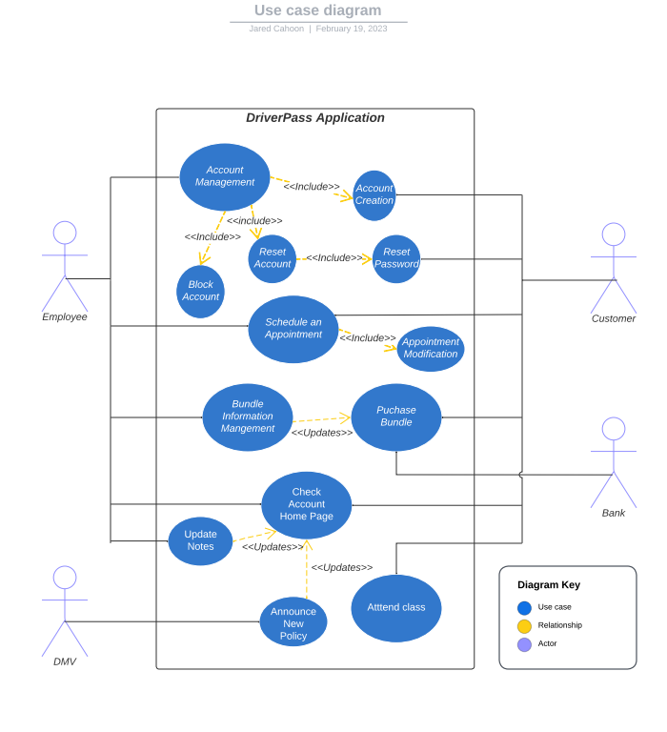

### UML Activity Diagrams

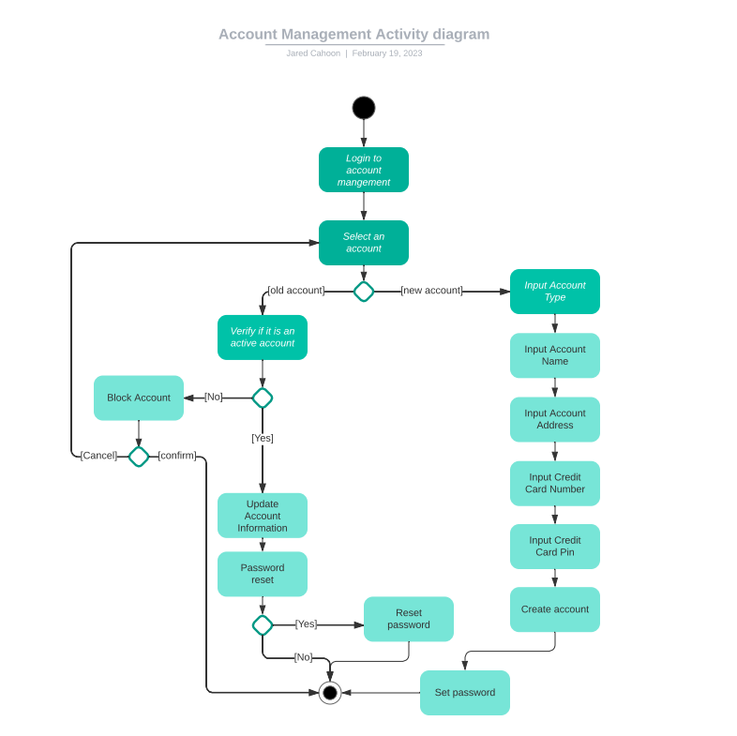

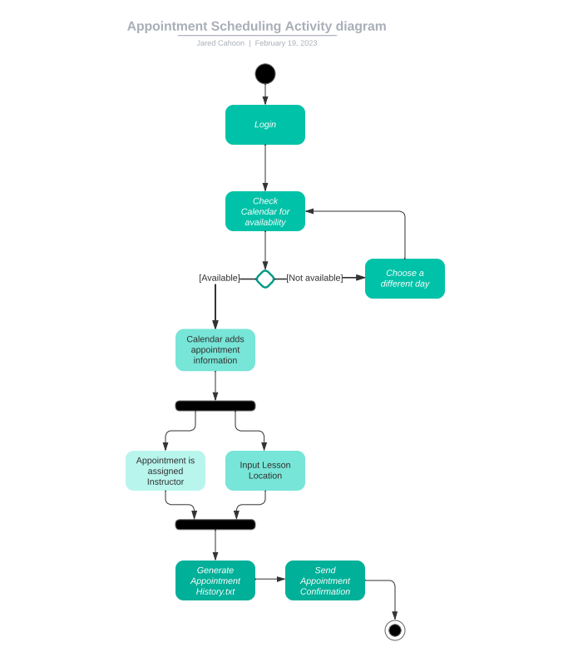

### UML Sequence Diagram

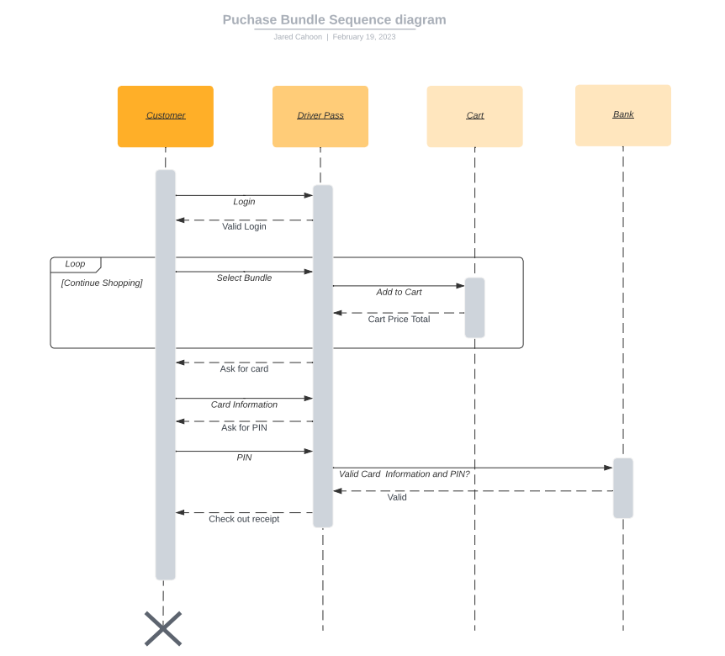

### UML Class Diagram

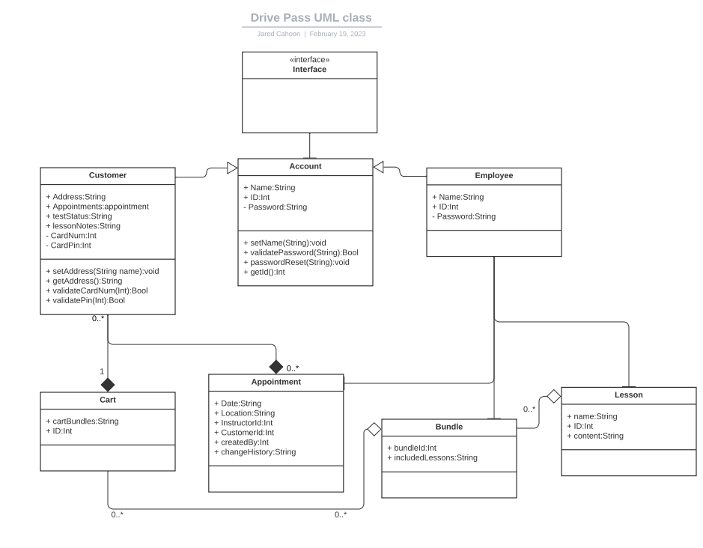

## Technical Requirements

As shown in the diagrams above, the driver pass system needs to connect with the internet and banking networks. The easiest way to interface with these systems is to enable a driver pass cloud. Customers access the system via web browsers, and web browsers access the cloud. The same applies to banking systems. A cloud would also allow the system to be accessible 24/7 and would be cost effective.

It is cost effective for many reasons but the two most important is that of flexibility and maintenance. Cloud providers often allow their customers to pay as you go, therefore, we will only need to pay for exactly as much space as our databases need or exactly as much bandwidth needed to process logins to the system. On the maintenance side, we would only need to ensure that the Driver Pass code is maintained and meets current industry standards. The cloud provider would keep the cloud and associated hardware maintained.

The benefit to creating a web-based application is that we will only need to ensure that the Driver pass system operates efficiently with Chrome, Firefox, and Safari. Each customer then can select the browser that fits their needs and is compatible with their devices.

Besides the software needed to actually write and create the application, the only hardware that is needed is a computer that is able to access the internet, and by extension the cloud. An IDE should be selected based off of the computer owned, visual studio or eclipse would be sufficient for our needs.